Raphaël Ingelbien

**Decadence**

Decadence was a word used to refer, often disparagingly, to late-nineteenth-century writers and artists whose worship of art for art’s sake went hand in hand with an open disdain for morality and for the values of their own societies. Often associated with modern French literature and its influence, decadent tendencies were observed in many different countries. In England, its main representatives were Oscar Wilde and various figures who were inspired by French examples and by the aestheticism of Walter Pater. Its main features were a cult of beauty, refinement and artificiality, a fascination for the paradoxical, the bizarre, the exotic and the perverse, and an iconoclastic attitude towards English values. While manifestations of decadence did earn a place in *fin-de-siècle* London culture, the phenomenon did not survive the spectacular fall of Oscar Wilde in 1895, but some of its ideas and attitudes point forward to modernism.

The terms ‘decadence’ and ‘decadents’ were first applied to French writers who proclaimed the absolute independence of art from all but purely artistic criteria. Writers like Théophile Gautier, Charles Baudelaire and Gustave Flaubert became notorious for their pursuit of formal perfection at the expense of morality. Their use of scandalous subject matters reinforced a suspicion that the ‘decadents’ were not so much a-moral as immoral artists who wanted to *épater le bourgeois* (viz. shock the middle classes). The first stirrings of decadence in England were found in the poems and essays of A.C. Swinburne, who championed Baudelaire’s work in the 1860s. Decadence later flourished as a new generation of writers and artists also came under the influence Walter Pater’s aestheticism between the late 1870s and the close of the nineteenth century. Figures like the Irish-born Oscar Wilde used Pater’s writings as a guide and devoted their time to an ostentatious pursuit of beauty at the expense of all other considerations.

While aestheticism and decadence are sometimes used as near synonyms, one can draw a distinction between aestheticism as a philosophy and decadence as a practice: when the reclusive Walter Pater died, Wilde commented “Was he ever alive?” Wilde himself was a very visible public figure whose dandyesque poses and witty talk became the sensation of London *soirées*; the fact that his persona is almost better known than his writings illustrates the decadent ambition to turn art into life. Other so-called decadents included various poets associated with the Rhymers’ Club in the 1890s (including Arthur Symons, Lionel Johnson and John Gray). Their associate W.B. Yeats later characterized them as a “tragic generation” owing to their personal failures and early deaths – a clear echo of the French *poète maudit* embodied by Arthur Rimbaud and Paul Verlaine. Some of their poems were marked by experiments with then unusual subject matters like modern urban life, which were partly inspired by Charles Baudelaire.

In the visual arts, the American-born James McNeill Whistler’s impressionist experiments with form were met with the strong disapproval of those who linked realist art, morality and social responsibility. The Victorian sage and art critic John Ruskin famously accused Whistler of “flinging a pot of paint in the public’s face”. The illustrator Aubrey Beardsley later caused a similar scandal with his highly stylized, morbid and sexually suggestive black-and-white drawings, partly inspired by Japanese woodcuts. Looking at Beardsley’s work, the leader of the social Arts and Crafts movement William Morris felt as if “a subtle corruption had invaded a pure ideal, as if beauty had lost its soul and, retaining outward fairness, seemed yet the more fiendish.”

Oscar Wilde produced something of a decadent manifesto in his preface to *The Picture of Dorian Gray* (1890/91), a novel where the protagonist enters a Faustian bargain in order to preserve his youthful beauty. If the novel’s ending was rather moralistic by Wilde’s standards, the preface flaunted the absolute independence of art: “There is no such thing as a moral or an immoral book. Books are well written, or badly written. That is all.” “All art is quite useless.” Despite Wilde’s scorn for utilitarian considerations, his promotion of art sometimes had social implications, as when he toured America to preach the gospel of beauty or gave lectures on interior design to wider audiences. Wilde also advocated a form of socialism as the path to truly self-fulfilling individual lives. The success of his comedies, filled with paradoxical dialogues and plots lines that blithely ignored conventional morality, further suggests that his decadent wit was not so shocking to the London theatre-going crowds. The cult of beauty also proved congenial to an emerging form of consumerism that could turn the beautiful into a saleable commodity. But both Wilde’s social consciousness and his popularity were eventually overshadowed by his sulphurous reputation. Dorian Gray’s decadent lifestyle, partly modelled on that of the protagonist of the French decadent writer Joris-Karl Huysmans’ *A Rebours* (*Against Nature*), amplified the rumours that gathered around Wilde’s own ‘immoral’ behaviour. The homosocial coteries where decadent dandies met were regarded with much suspicion, as was their fascination for Greek art and all things unnatural. In 1895, Oscar Wilde was convicted of homosexual acts and sent to prison for two years at the end of a highly publicized trial; in the backlash that ensued, decadence and its aestheticist underpinnings became anathema.

The associates of decadence who managed to survive the debacle took their aestheticist principles into safer parallel directions, like Symbolism (see e.g. Arthur Symons’s 1899 survey of modern French literature entitled *The Symbolist Movement in Literature*) or the Celtic Twilight, through Yeats’s involvement in the Irish literary renaissance. Yeats’s own later career went on to bridge chronological gaps between *fin-de-siècle* decadence and twentieth-century modernism. The insistence on the autonomy of art, the flouting of English middle-class morality, the foreign origins and cosmopolitan outlook of leading decadents, the experiment with pure form and with modern subject matters are all features that recur in modernist aesthetics. If the decadent Wilde was too tainted or too compromised a figure for many modernists to acknowledge as a model, he still remains the icon of a movement that paved the way for several aspects of modernist art.

References and further reading

Primary texts

Beckson, Karl, ed. (1981) *Aesthetes and Decadents of the 1890s. An Anthology of British Poetry and Prose*. Chicago: Academy Chicago Publishers.

Wilde, Oscar. (2003) *The* *Complete Works of Oscar Wilde*. London: Collins.

Works on decadence

Bernheimer, Charles. (2002) *Decadent Subjects: The Idea of Decadence in Art, Literature, Philosophy, and Culture of the Fin-de-Siècle in Europe*,Baltimore: Johns Hopkins University Press.

Charlesworth,Barbara. (1965) *Dark Passages: the Decadent Consciousness in Victorian Literature*, Madison: University of Wisconsin Press.

Denisoff, Dennis. (2007) ‘Decadence and Aestheticism’ in *The Cambridge Companion to the Fin de Siècle*, ed. Gail Marshall, Cambridge, Cambridge University Press, pp. 31–52.

Gagnier, Regenia. (1987) *Idylls of the Marketplace. Oscar Wilde and the Victorian Public*, Stanford: Stanford University Press.

Gaunt, William. (1975) *The Aesthetic Adventure*, 2nd edition, London: Jonathan Cape.

Gilman, Richard. (1979) *Decadence: The Strange Life of an Epithet*, New York: Farrar, Strauss and Giroux.

Ledger, Sally and Scott McCracken, eds.(1995) *Cultural Politics at the Fin de Siècle*, Cambridge: Cambridge University Press.

MacLeod, Kirsten. (2006) *Fictions of British Decadence: High Art, Popular Writing, and the Fin de Siècle*, Basingstoke: Palgrave Macmillan.

Sturgis, Matthew. (1995) *Passionate Attitudes: English Decadence of the 1890s*, London: Picador.

Weir, David. (1996) *Decadence and the Making of Modernism*, Amherst: University of Massachusetts Press.

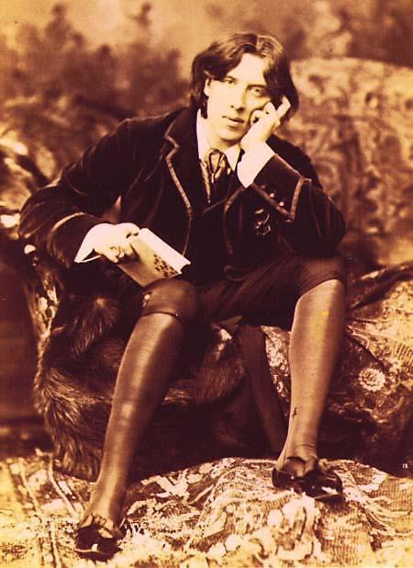

Oscar_Wilde_(1854-1900)_in_New_York,_1882._Picture_by_Napoleon_Sarony_(1821-1896)

<http://iconicphotos.wordpress.com/?s=oscar+wilde>

**NB:** Sarony was mad when the Burrow-Giles Lithographic Company had marketed unauthorized lithographs of above photo in 1884. Titled ‘Oscar Wilde No. 18′, it was just one of a series of portrait Sarony took of Wilde two years before. (Inspired and not to be outdone by Sarony’s portrait, Wilde tried his hand at portraiture of another sort *The Picture of Dorian Grey* in 1890)*.* The constitutionality of the extension of copyright laws to photographs was highly debated; finally, *Burrow-Giles Lithographic Co. v. Sarony* reached all the way tothe Supreme Court, which unanimously upheld the power of Congress to extend copyright protection to photography.

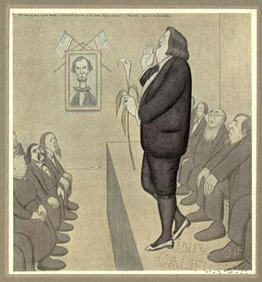

Beerbohm, Max. ‘The Name of Dante Gabriel Rossetti is heard for the first time in the United States of America. Time: 1881. Lecturer: Mr. Oscar Wilde.’ (1922)

Beerbohm, Max. *Rossetti and His Circle*. London: William Heinemann, 1922.

Plate 22

6 1/2 x 4 1/4 inches

Found on The Victorian Web <http://www.victorianweb.org/authors/mb/dgrcircle22.html> [“This image may be used without prior permission for any scholarly or educational purpose.”]

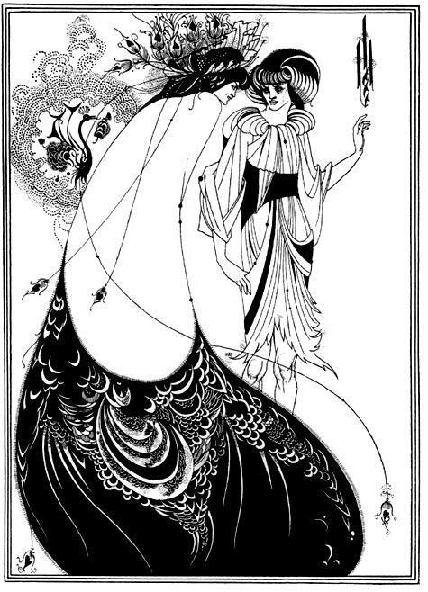

Aubrey Beardsley, ‘The Peacock Skirt’ (1894) (illustration for Oscar Wilde’s *Salome*)

<http://www.victorianweb.org/art/illustration/beardsley/3.html>

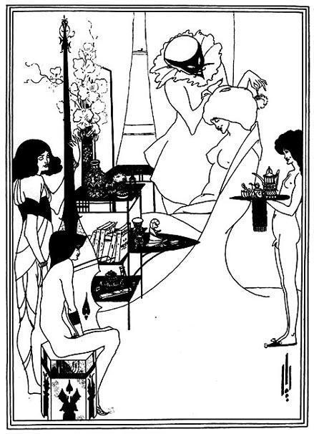

Aubrey Beardsley, ‘The Toilette of Salome’ (1894) (illustration for Oscar Wilde’s *Salome*)

<http://www.victorianweb.org/art/illustration/beardsley/10.html>

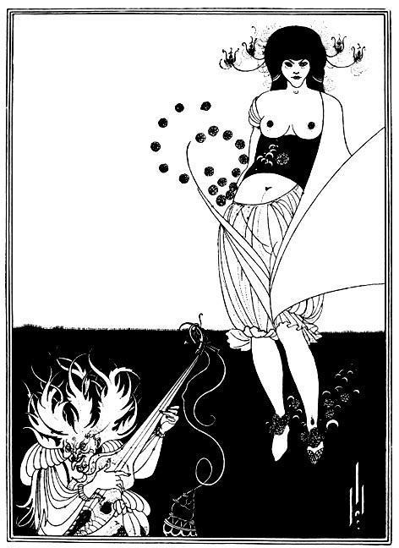

Aubrey Beardsley, ‘The Stomach Dance’ (1894) (illustration for Oscar Wilde’s *Salome*)

<http://www.victorianweb.org/art/illustration/beardsley/8.html>